**DISABILITY WORKING GROUP**

**Key Messages 21 March 2025**

**Easy Read Format**

**Members**: John Marrable, Kirsten Dixon, Paula Waby,

Adam Hall, Jacqui Eggleton, Jaime Randhawa, Te Aroha Aratangi,

**Standing members**: Kathryn Harkin,

**Apologies**: Philippa Henderson, Isabelle Jenkins

The Disability Working Group members met on Friday 21 March 2025

Becks New and Sara Goff from Toitu te Waiora introduced themselves.

 They are a qualifications and standard setting organisation who prepare qualifications for community, health and disability, social services.

They are currently working on two new qualifications.

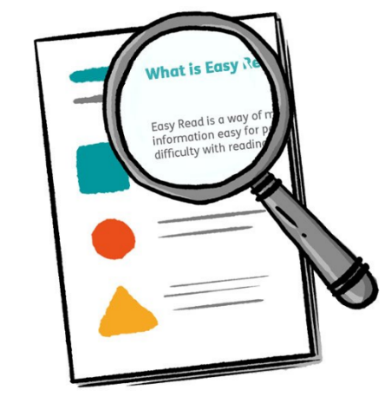 Also looking at improving and including areas identified that this disability education has overlooked.

They want to know what they should include in this training.

The Disability Working Group Members suggested:

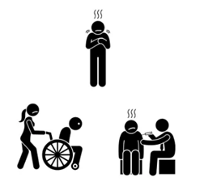

1. Differences between disability, illness, disease etc. regarding skills, e.g. person in a wheelchair.
2. Better communication needed between whanau (family) members and support workers to know how things are going and making it part of the training. Also, professional / moral limits.
3. A lot of people do not understand Deaf culture and might have the wrong idea.
4. 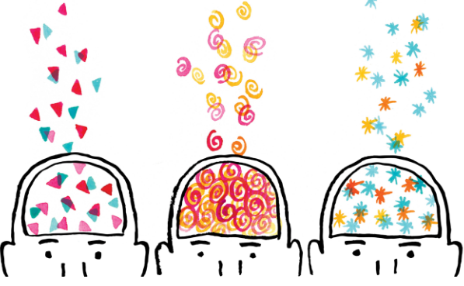 Give neurodiverse people time to speak. Shouldn’t take over and finish the sentence just because it’s faster. Allow them to be independent.

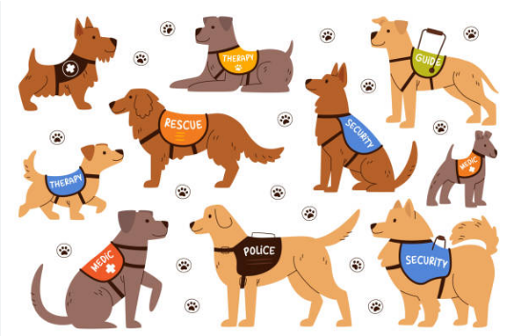

1. Understanding the role of a working dog.

Becks advised that further meetings on ZOOM are being held and members invited to join in.

Will be calling for interest in steering group members as well.

Hidden Disability Sunflower is being rolled out on 31st March in Dunedin and Invercargill.

Staff are excited and over 400 have completed the training so far.

 Hidden Disability Sunflower will be rolled out to Rural hospitals later this year.

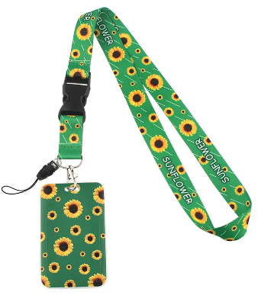

Some lanyards available for consumers.

John and Kathryn presented the revised Disability Action Plan for 2025.

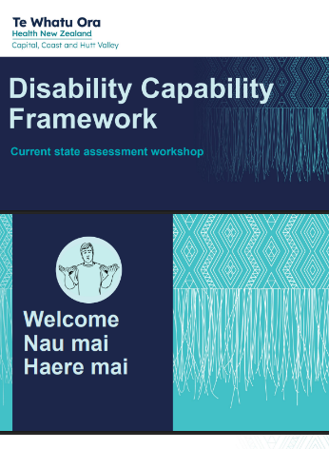

They have aligned this with the Te Waipounamu (South Island) regional disability plan, as well as the “Disability Capability Framework” designed by the national team.

Some actions have been removed – these are ones that are more likely to be made nationally such as accessibility changes to the website.

**Round Table:**

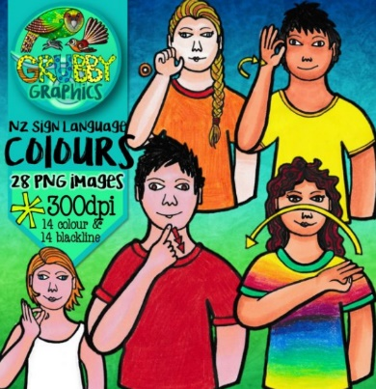

One member working with hospital around upcoming birth, to ensure that Deaf culture and NZSL are used. Has also had students working with her and hoping they will go on to learn NZSL.

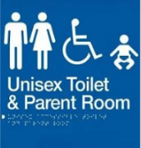

Need for a whānau (family) toilet in Invercargill hospital as members have had bad feedback when taking older disabled children in to a toilet.



Praise for the Southland audiology service.

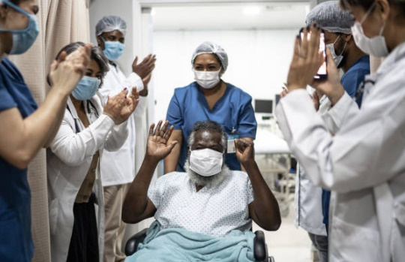Members gave many examples of needing to repeat their needs several times to different health staff.

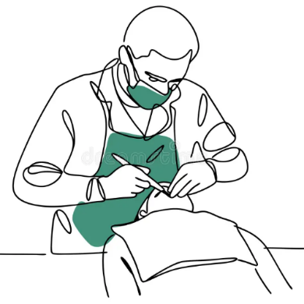Question as to whether there is a dentist’s organisation like WellSouth?

Question about accessibility as cannot get wheelchair into a dentist

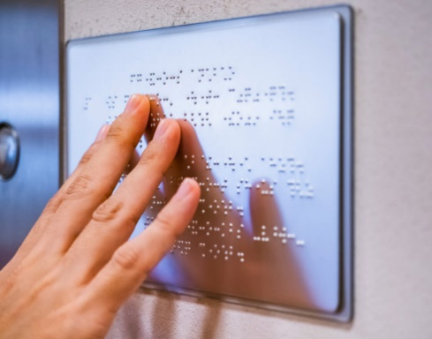

Noted that the New Dunedin Hospital will have Braille on signage as well as Left Hand or Right Hand signage for toilets.

A member went to the national ASID conference for intellectual disability which was very rewarding.

ASID is short for the Australasian

Society for Intellectual Disability.