CIR Inventory Portal Updates

Terms
Record Consumption button – to be used to record consumption/stock on hand (record as consumption when 1+ doses out of a vial have been used
Stock Adjustment button – to be used by VLC to correct any incorrect entries
Stock Re-work button – Used to rework vaccine packs into vials
Wastage button – Used to record any stock that has been wasted (opened and not used or expired)
Quarantine button – Used if any stock has to be quarantined for inspection/before being wasted

QA approval – with Vaccine Logistics Coordinator
MOH approval – approved by Vaccine Logistics Coordinator, with MoH logistics for approval
Draft – not submitted for QA approval
Dispatched – sent but not receipted
Closed – receipted or order rejected/cancelled by QA/MOH

New Orders

- Search provider by typing name into Search Bar on CIR home page and clicking enter on keyboard (DON’T use mouse to select drop down option). Click on Profile name that is Facility type
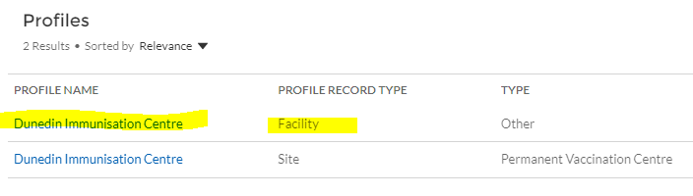
- If Stock Update Warning will need to update for each of the products listed – record consumption as ‘0’. See Consuming Vaccine

- If there are unreceipted orders, please receipt now

- Select New Order button

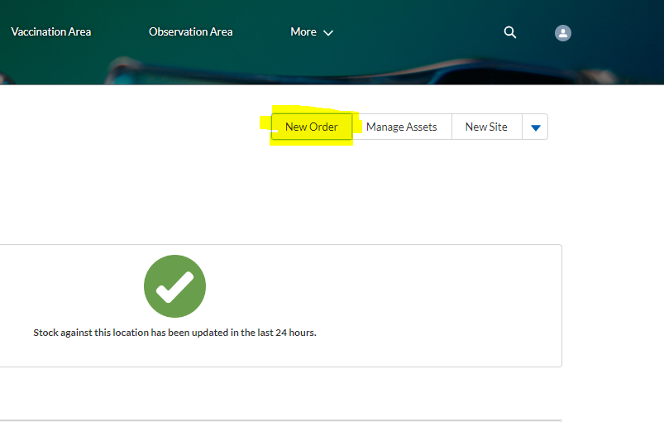

- Always Select ‘Supplier’

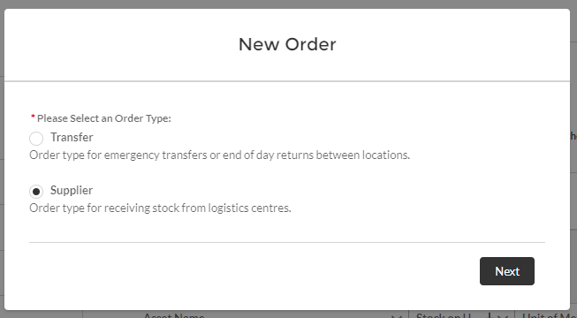

- Click on Create Order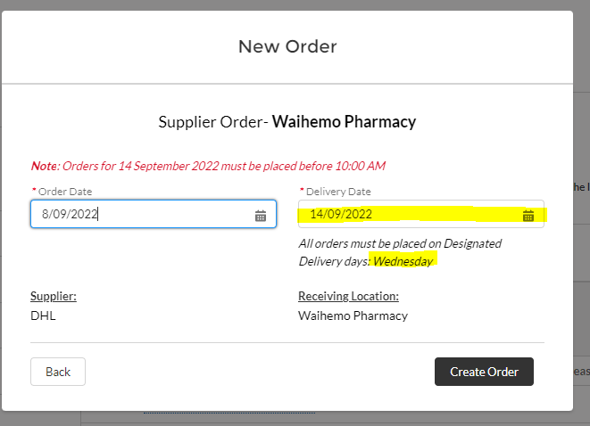

- Where is says ‘No demand found for XXXX’ this is the delivery date
Click on Add Products

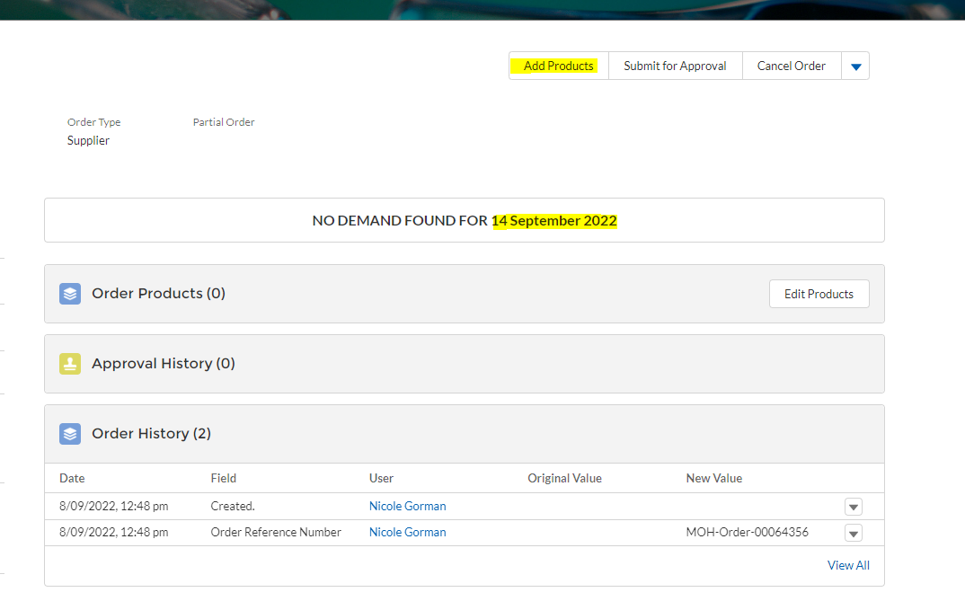

- Select products to order and then select Next
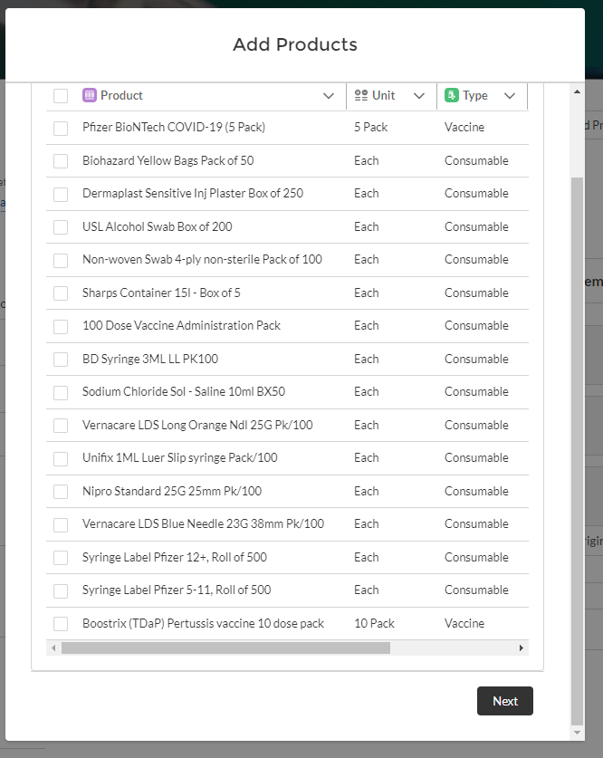

- Amend quantity as required and select Next
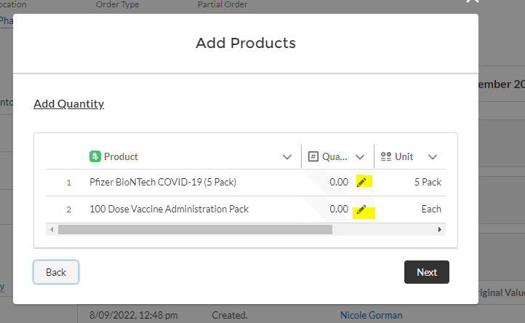

- Check order is correct then select Submit for Approval.
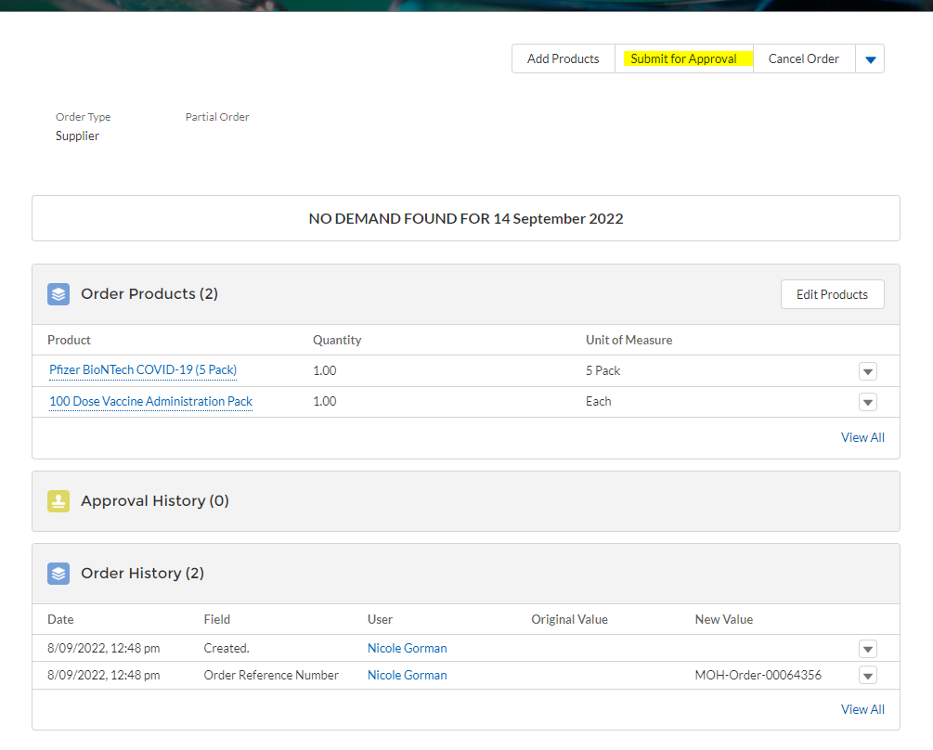
With all orders, don’t forget to ‘SUBMIT FOR APPROVAL’ or your order will sit in DRAFT

Receipting Vaccine and consumables after Delivery
Orders received will show as Dispatched in Incoming Orders section of portal
- Click on Order number
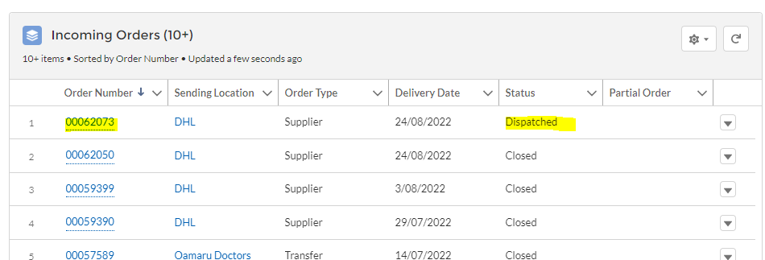

- Click on Receipt order
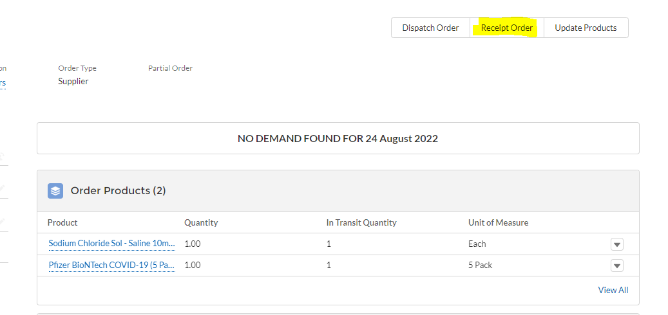

- Amend any quanities as required then click on Receipt Stock
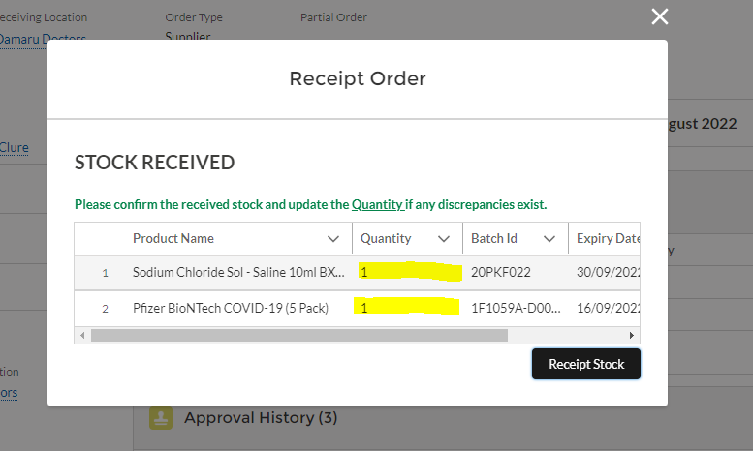

Once vaccine has been recieved need to rework stock into vials – see ‘Reworking Vaccine from Packs into Vials’.

Reworking Vaccine from Packs into Vials After Receipting

- Select pack to rework from assets section
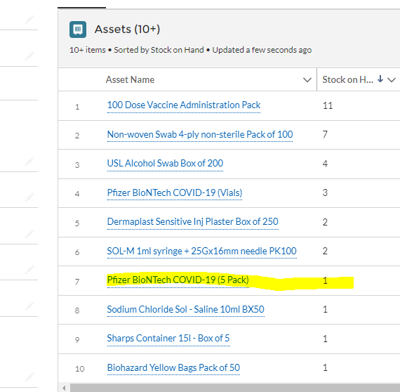

- Select the batch number and click on Stock Re-work

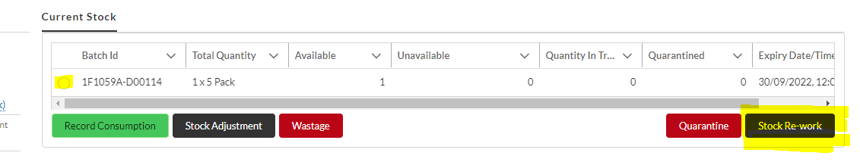

- Select the line with Unit of Measure showing vials
- Related Product Quantity is the quantity of the product reworking ie. 5 = 5-pack; 1 = single vial
- Unit of Measure is the units working the product into (choose vials)
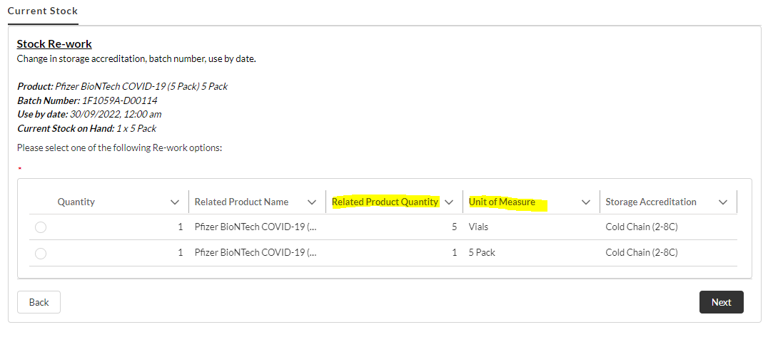

- Enter quantity of stock (ie. 5-packs) being re-worked and enter Complete.
This screen shows current Stock on Hand and Max Quantity can re-work.

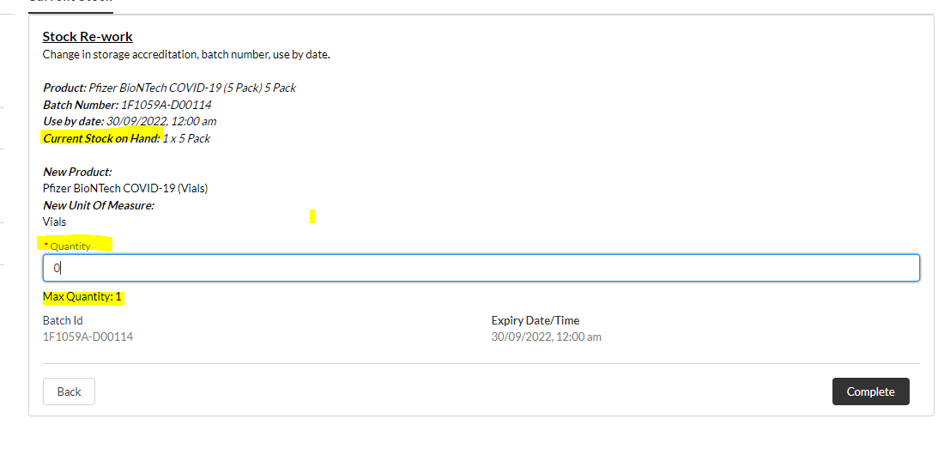

Consuming Vaccine after daily usage

Providers should record consumption daily. If not used any vials then record consumption as ‘0’.
- Click on asset name to record consumption for

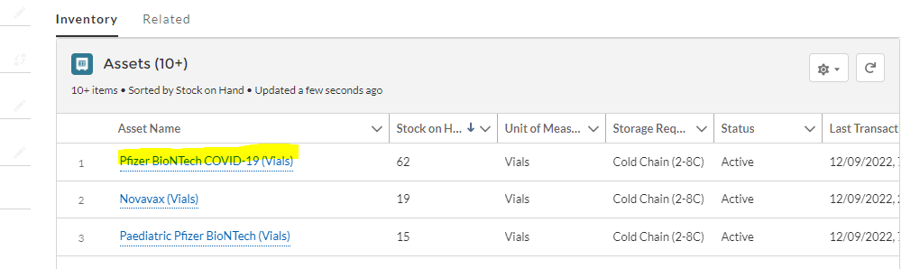

- Select batch number and click on Record Consumption
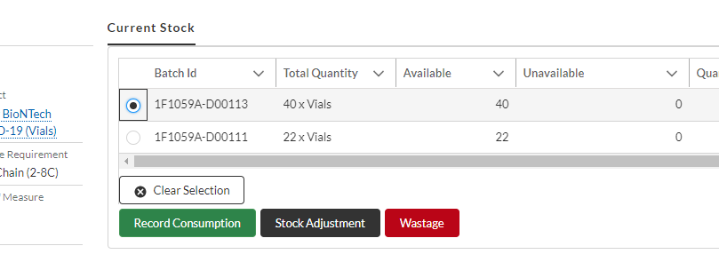
- Record SOH
- Select either ‘Record Consumption’ (actual amount used) or ‘Record Stock on Hand (Amount at End of Day)’
- Enter the amount – if not used any, select Record Consumption and enter 0
- Amend the date if necessary
- Click Save

Recording Wastage

All products including consumables and saline that have expired need to be wasted out of the CIR inventory portal.

- Click on asset name to record wastage for

- Select batch number and click on Wastage
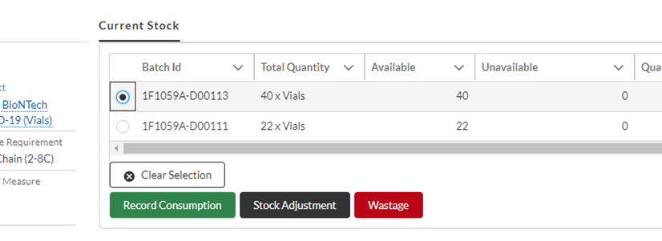
- Enter Wastage information
- Enter date wasted
- Enter quantity wasted
- Select Wastage reason from drop down box and ALSO type this reason in the Comments box
- Click on Save

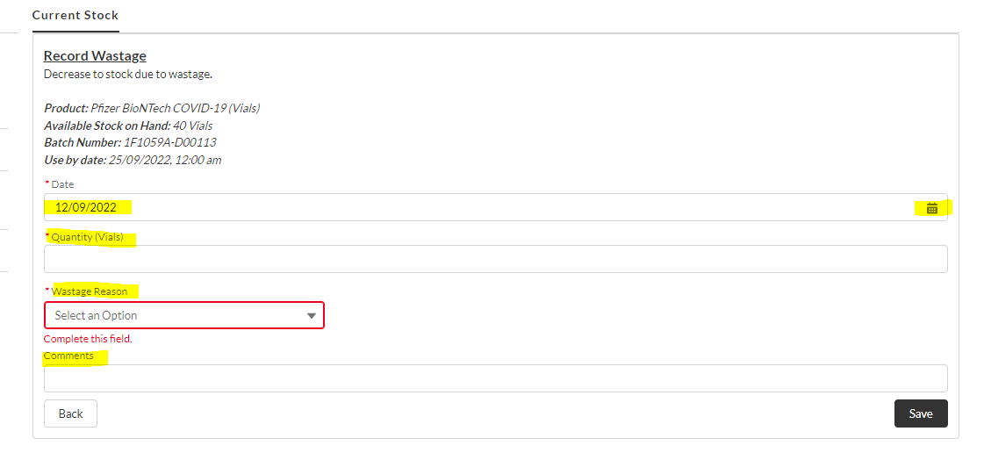

Cancelling orders
- If not yet QA approved then reject order.
- If with MoH approval email MoH LOG requesting cancellation of the order. Include order number and provider name.

