Connecting Communities Funding Application Form

Community group/organisation details
Name
Does your community group/organisation have a Charitable Trust/services registration number or NZBN?
Yes/No (If yes, please include here)
Your address

Contact details
Details of the key person we will contact if we have any questions
Full name

Phone number

Email address

Description of activity or event
Please describe the activity or event to be funded. Include where this will happen and who is expected to attend

Please describe how it will benefit those who attend, or what you hope to achieve

If it’s an event:
Start date:
End date:
Dates to be confirmed:
Location:

Fund
Please state the total amount applied for and how it will be spent

Please include details of any quotes, if appropriate

Mechanism for payment: Bank verification
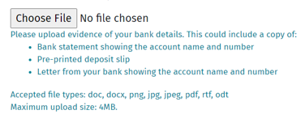
Please scan and load your bank logo and account number
If your group doesn’t have a bank account, please attach the supplier(s) quotes for the activity, event or equipment you want to purchase (the quote should include their bank details).
If neither of these options apply, please contact us for a chat.

