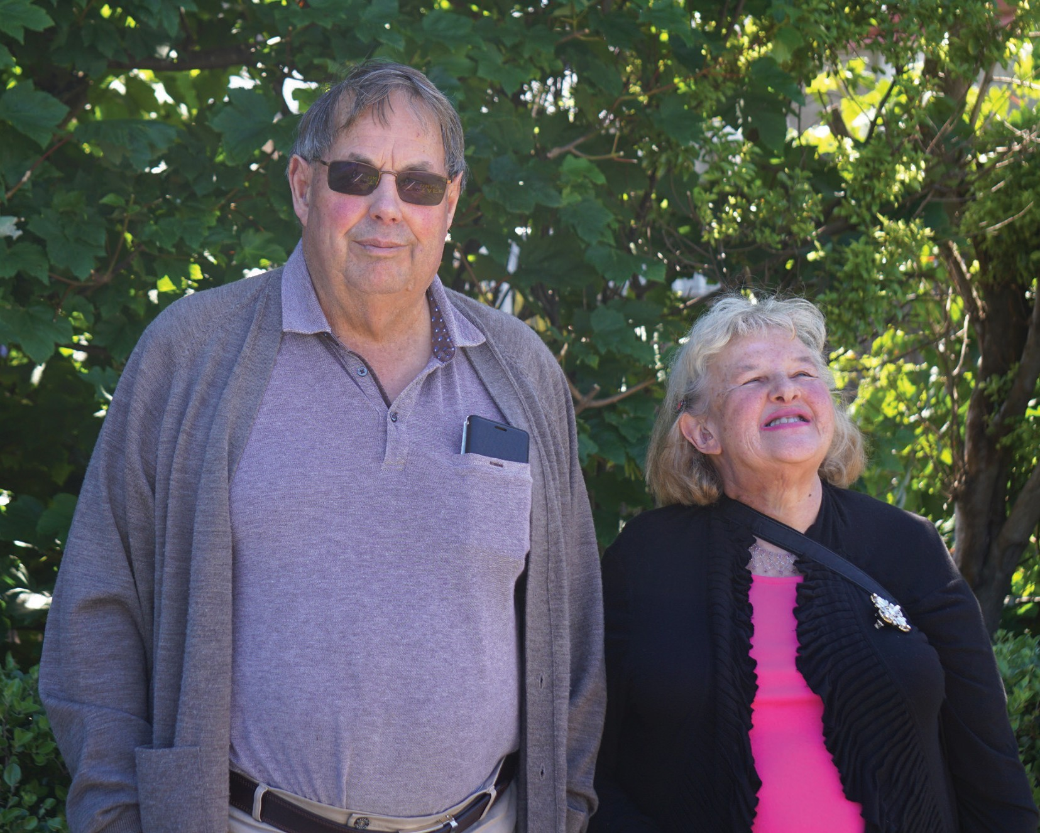
2021

Disability Strategy
Rautaki Hauātanga

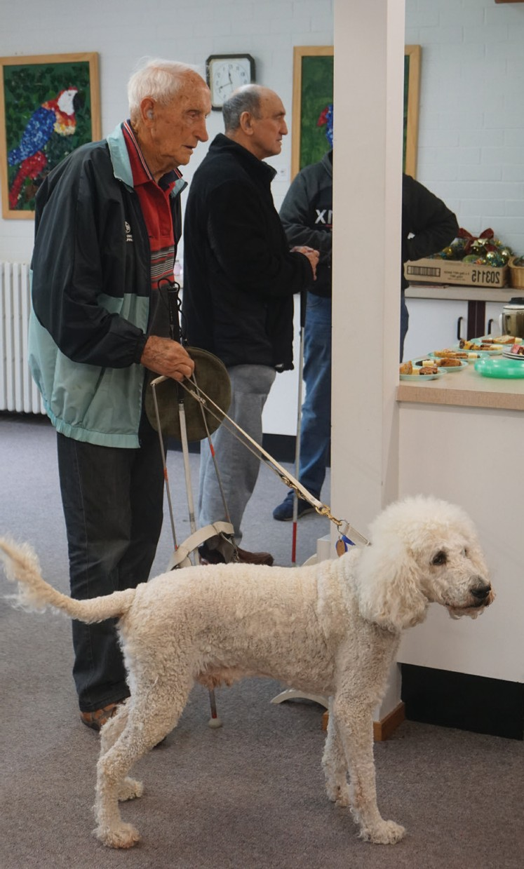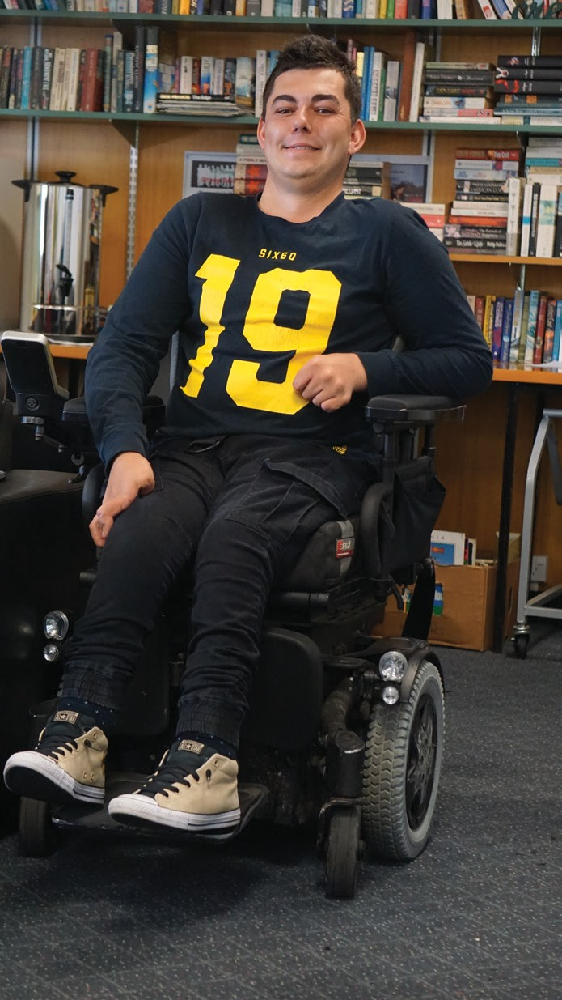

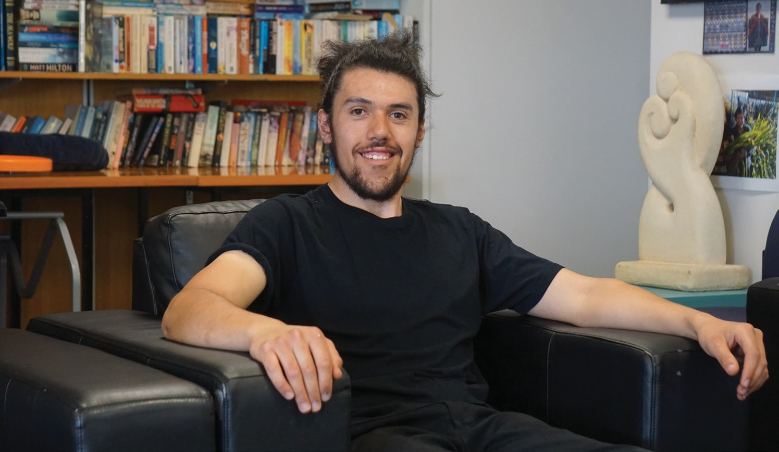

Foreword

Contents
Ihiraki
01
Kupu Whakamahuki nā te Tumuaki

Introduction
02
Kupu Whakataki

Quick Facts about Disability in New Zealand
04
Meka mō te Hauātaka ki Aotearoa

Definitions used in this Strategy
05
Whakamāramataka ko whakamahia ki tēnei rautaki

Policy Context for New Zealand
07
Horopaki Kaupapa Here ki Aotearoa

Current Southern DHB Context
09
Horopaki o nāianei ki Piki te Ora

Southern DHB Disability Strategy
11
Rautaki Hauātaka

Vision
Wawata

Priorities
Mahi Mātuatua

Bold and Purposeful
13
Whai take, whai māiataka

Inclusive of Individuals, Whānau or Family and Community
15
Mahi Kātahi ki te Takata, te Whānau me te Hapori

Equitable, Responsive and Accessible
17
Tōkeke, Kātoitoi, Wātea

Southern DHB Values
19
Kā Uara o Piki te Ora

Thank you to our local champions whose photographs are featured in this document: Tony and Carolyn Weston, Elmer Curry, Jack Lovett-Hurst, William Todd, John Marrable, Mhari Baty,
Peggy Lavinia Whio Peek, Rodger Strong, Paula Waby, David Allen, Members of Blind Low Vision Southland branch.

Tēnā Koutou katoa,

Foreword from the the Board and Chief Executive
Kupu Whakamahuki nā te Tumuaki

We are pleased to present the Southern District Health Board Disability Strategy, which describes our vision and goals we will follow to provide equitable health and disability services throughout the southern district. The vision recognises the need to remove barriers for disabled people and provide well integrated services that are responsive to them and their whānau, enabling them to live well and participate within their community.

The strategy, developed in line with the New Zealand Disability Strategy 2001 and the United Nations Convention on the rights of Persons with Disability, also aligns with and will sit alongside a number of Southern DHB and wider health initiatives as expressed through Southern Health. These include the Primary and Community Care Strategy and Action Plan; the Southern Strategic Health Plan; the Southern DHB Quality Framework; the Southern Digital Strategy; and the Southern Workforce Strategy. All these initiatives focus on developing an equitable and coherent system of care across the southern district.

Consultation with the community has led the development of this strategy. The goals incorporated into the Disability Strategy reflect the request of disabled people, whānau, family, disability and health support providers to recognise and address the unique situation of each individual. The community requested that Southern DHB provide leadership in moving the district to one where disabled people are able to achieve their goals and aspirations.

The goals and actions will take time to achieve and will require prioritising. As contracts with providers are renegotiated, there will be a requirement to address the goals and actions of the Southern DHB Disability Strategy as appropriate to their service. Some actions will be able to be addressed within the short term, while others might take longer to achieve. We are committed to achieving all goals and leading the southern district into a future where disabled people, whānau and families are living well within our community, barriers are eliminated, and individuals have the ability to access appropriate services.

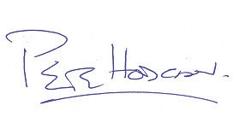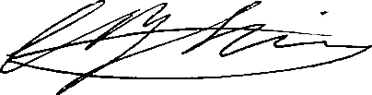

Pete Hodgson
Board Chair
Chris Fleming
Chief Executive

HE KIWAHA

Introduction
Kupu Whakataki
Pupuhi rau ki raro Just like a blown leaf falls to provide
Tipua ai ki ruka Sustenance for life to be born again
Oraka atu anō e The seed planted well may blossom
Te kakano e rui mai nā Again in Rakiatea. Ka puawai i Rakiatea
Auē!

HE WHAKATAUKĪ
Ui mai koe, he aha te mea nui o tēnei ao?
If you were to ask me what is the most important thing in the world Māku e ki atu, he takata, he takata, he takata
I would reply, tis people, tis people, tis people

HE MIHI
I te tuatahi, kai te mihi mātou ki te Atua, nāna i hanga māi kā mea katoa Kai te mihi atu, kai te taki atu ki o tātou mate kua haere ki tua atu o te
tatau pounamu, haere, haere, haere atu rā. Waiho rātou ki a rātou, tātou anō ki a tātou.
Huri noa ki a koutou kā kanohi ora o Kāi Tahu, Kāti Mamoe me Waitaha hoki, Ki a koutou e mau ana te te mana whenua, te mana moana mō ka uri
katoa o ia hapū, o ia hapū.
He mihi miharo hoki ki kā hau e whā, ko ka takata o ia hāpori, o ia hāpori o Araiteuru, a Murihiku hoki.
Ānei he taoka, kua whakapakari ana he rautaki hauātaka mō tātou katoa. Nō reira, tēnā tātou katoa.

“ It’s not an optional extra to understand someone
entering the health system has a condition or impairment. I think acknowledging vulnerability needs to start from management down. It needs to be shown in how management speak to it, the language we use and the language we don’t use. People with disabilities
”
– we are all people. This is our community.
- Quote from consultation

Rationale

Introduction continued
Kupu Whakataki

Pūtake

Disabled people, tāngata whaikaha and Deaf people, have the right to fully access services provided by the Southern District Health Board (Southern DHB) and to participate within their community. The Southern DHB has responsibility for contracting multiple health and disability services throughout the district to provide the population with health and disability support. Services include primary health, disability support, aged care and hospitals. This Southern DHB Disability Strategy provides a framework for the funded services to ensure that disabled people, tāngata whaikaha and Deaf people within the Southern DHB district are engaged with them, have the support they require to participate in their community, and are represented at all levels of the Southern DHB. Some funded services are already working closely with voluntary groups to
strengthen health structures through the Southern Health pathway to enable better health, better lives, Whānau Ora, and these relationships will further assist the Southern DHB to meet the goals expressed in the Strategy.

Introduction

Kupu Whakataki

The personal experience of health and disability services drives the focus for this strategy.
Acknowledging the importance of hearing from disabled people, tāngata whaikaha, Deaf people, whānau and the wider community, the Strategy has been developed through a process of consultation. Appreciating the value of an open consultation process, the Southern DHB commissioned the Donald Beasley Institute (DBI), a Dunedin-based disability research organisation, to facilitate the development of the Strategy. http://www.donaldbeasley.org.nz

A Disability Strategy Steering Committe was formed. Its members are Chris Ford , Jasmine Taylor, Victoria Bryant, Kate Bateman, Paula Waby, William Luskie Sarah Derrett and Martin Burke.

Consultation followed a co-design approach and included people with diverse experience of the health and disability sectors, both as consumers and providers.

A strong message from the people who participated in consultation was that they wanted a Strategy that would drive the longer- term goal of the New Zealand Disability Strategy
for disabled people to be fully included within society. To achieve this goal within the Southern DHB district, the Strategy includes a number of actions to which the Southern DHB commits.
Some actions will be immediate, while others will take longer to enact. All actions will be evaluated and reported through appropriate workplans.

People being consulted also asked for clarification about the term ‘disability’ as many people who require reasonable accommodations might not consider themselves disabled. For the purpose
of the Strategy, people with physical, intellectual, cognitive, mental or sensory impairments, people with long-term (chronic) or psychosocial
conditions, or any other impairment are included. The Strategy does recognise that a person’s impairment will not necessarily inform their identity. People belong within various groups which might more strongly influence their identity.

People who are engaged with their health and disability service are more likely to have positive care experiences and subsequently better health outcomes. The Strategy includes actions that focus on the experiences of disabled people, tāngata whaikaha and Deaf people to ensure that they and their family or whānau feel informed, engaged and supported to manage their health and are able to live satisfying lives within their community.

Southern DHB is responsible for planning, funding and providing health and disability services to the population living south of the Waitaki river (over 300,000 people). It is the largest DHB in New Zealand by geographical area.

Quick Facts about Disability in New Zealand
Meka mō te Hauātaka ki Aotearoa

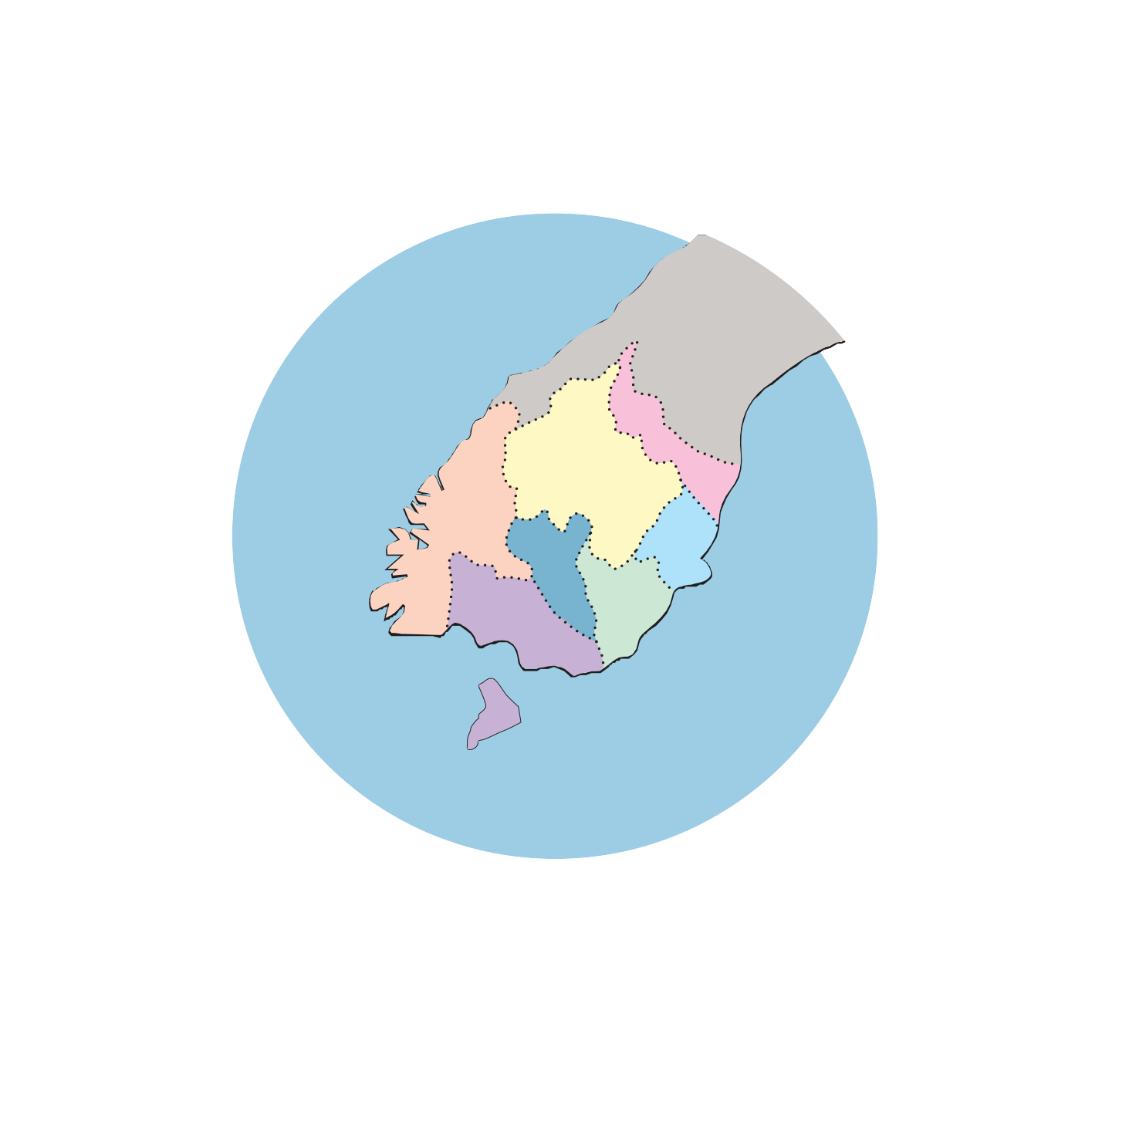
The New Zealand Disability Strategy was first released in 2001, with an updated Action Plan released in 2016, with the aim to make New Zealand a more inclusive and accessible society.

Using data from the 2013 New Zealand Disability Survey, interRAI and the Southern DHB we know that:

People over 65 years of age were more likely to be disabled (59%) than adults under 65 years of age (21%) or children under 15 years
of age (11%)
24 % of the New Zealand population identified as disabled

It is not unusual for people to have multiple impairments

In the Southern DHB district 79,000 people identified as disabled, representing 26% of the total population
Māori (32%) and Pacific (26%) people had
higher-than-average disability rates, after adjusting for differences in ethnic population age profiles

The Southern DHB currently supports approximately 4,500 adults over 65 years of age within Home and Community Support Services

Disabled people are more likely to self-assess their health as poor when compared to non- disabled people

Mild or greater cognitive impairment is common (approximately 58%) in those people aged 65 years and over who are assessed for home care support

In addition, people express feelings of

To read the 2016-2026 New Zealand Disability strategy visit: https://www.odi.govt.nz/ nz-disability-strategy
loneliness (23%) and informal carers express feelings of distress, anger and depression (23%)

In the 2018 census 10.5% (34,137) of the population in the Southern DHB district identified as Māori. An estimation of tāngata whaikaha for the Southern DHB would be approximately 10,000 people, based on the proportions identified through the 2013 Disability Survey.

Co-design

Definitions used in this Strategy
Whakamāramataka ko whakamahia ki tēnei rautaki

Hoahoa-tahi
Co-design is defined as a method for partnering with patients, consumers and service users right from the beginning of service planning to ensure a closer alignment of service delivery with what will work best for service users.
(From healthnavigator.org.nz)

Deaf

Turi
For many Deaf people their Deafness is not seen by them as a disability. They form a distinct community, having their own culture and language (New Zealand Sign Language). (Adapted from Deaf Aotearoa website.)

Disability

Hauātaka
Long-term physical, mental, intellectual or sensory impairment which in interaction with various barriers may hinder the person’s full and effective participation in society on an
equal basis with others. (Adapted from the United Nations Convention on the Rights of Persons with Disabilities (UNCRPD) and the NZ Disability
Strategy 2016-2026.)

Equity

Tōkeke
Equity recognises different people with different levels of advantage require different approaches and resources to get equitable health outcomes. (From Ministry of Health, 2019.)

Hard of hearing

Turi
A hearing impairment that is defined by the World Health Organisation to be moderate or worse hearing in the better ear.

Hidden Disability

Hauātaka huna
Hidden (invisible) disabilities include fatigue, pain, cognitive and mental impairments, hearing and visual impairments, and psychosocial impairments that might not be obvious but that impact on the person’s movement, senses or activities. (Adapted from https://invisibledisabilities.org/what-is-an- invisible-disability .)

Health

Hauora
Health is a state of complete physical, mental and social well- being and not merely the absence of disease or infirmity. (From https://www.who.int/about/who-we-are/constitution.)

Long-term (or chronic) conditions

Mate mauroa
Long-term conditions are ongoing, long-term or recurring conditions that can have a significant impact on people’s lives. (Ministry of Health, 2018.)

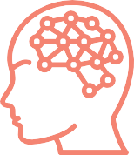
Psychosocial disability

Hauātanga ā-hinekaro, ā-pāpori
The UNCRPD describes psychosocial disability as the experience of people with impairments and participation restrictions related to mental health conditions. These impairments can include a loss of ability to function, think clearly, experience full physical health, and manage the social and emotional aspects of their lives

Reasonable Accommodation

Nohoaka pai
Reasonable accommodation means necessary and appropriate modification and adjustments to ensure persons with disabilities enjoyment or exercise on an equal basis with others of all human rights and freedoms. (Adapted from the UNCRPD.)

Tāngata whaikaha
Tāngata whaikaha is the term used in the Whāia Te Ao Mārama (Māori Disability Strategy) to describe a Māori person with a disability. The term refers to people who are determined to do well and create their own opportunities.

Universal design

Hoahoa whānui
Universal design means the design of products, environments, programmes, and services to be usable by all people, to the greatest extent possible, without the need for adaptation or specialised design. It includes assistive devices for particular groups of persons with disabilities where this is needed. (Adapted from the
UNCRPD.)

Underpinning the Southern DHB Disability Strategy are important international and national documents that address the rights of disabled people.

Policy Context for New Zealand
Horopaki Kaupapa Here ki Aotearoa

United Nations Convention on the Rights of Persons with Disabilities (UNCRPD)

Te Kawenata o te Rūnaka Whakakotahi i kā Iwi o te Ao mō kā Tika o kā Tākata Hauā

New Zealand ratified the UNCRPD in 2008. Under this international convention, New Zealand is expected to “promote, protect and ensure the full and equal enjoyment of all human rights and fundamental freedoms by all persons with disabilities, and to promote respect for their inherent dignity”.

The UNCRPD is based on the social model of disability alongside rights-based models. The social model of disability recognises the person as having an impairment, but it is through their experience of barriers to their participation that they are disabled. This shifts the focus from the individual’s deficiencies (as assumed by the medical model of disability), to identifying and removing the barriers that prevent their participation within society.

Within the UNCRPD there are a number of articles relevant to the Southern DHB Disability Strategy. The relevant article(s) are identified alongside the Southern DHB action.

Te Tiriti O Waitangi

Te Tiriti O Waitangi, as the founding document of Aotearoa New Zealand, sets out the relationship between Māori and the Crown. Three key principles are identified in the Treaty of Waitangi: partnership, participation and protection. These principles provide direction for achieving Māori aspirations and contributions within the health and disability sectors. He Korowai Oranga provides the overall strategic direction to the health and disability sector to achieve the best health outcomes for Māori.

The vision of Pae Ora (healthy futures for Māori) is reflected in Whāia Te Ao Mārama 2018-2022 (The Māori Disability Action Plan; MDAP), which provides a vision for tāngata whaikaha to pursue a good life with support. Importantly, Whāia Te Ao Marama reinforces that most tāngata whaikaha identify as Māori first. The importance of their cultural identity, which encompasses language, whānau, cultural principles, practices, and linkages to the land through genealogy, is paramount to how they live their day to day lives in both Te Ao Māori and Te Ao Pakeha. In order to achieve
a good life with support, Whāia Te Ao Mārama incorporates six goals, three of which relate to participation, in health and disability services (goal 1), Te Ao Māori (goal 3), and their community (goal 4). Further goals aim for tāngata whaikaha to have control over their disability support (goal 2), receive disability support services that are responsive to Te Ao Māori (goal 5), and have informed and responsive communities (goal 6). Overall the goals reflect the Articles of Te Tiriti.
These six goals are incorporated into the Southern DHB Disability Strategy.

Lead and respond to the recommendations from the Waitangi Tribunal Hauora Report Wai2575 Health Services and Outcomes Kaupapa Inquiry stage one and continue to support subsequent stages.

Aotearoa New Zealand Health and Disability Strategies and Policies

Kā Rautaki, kā Kaupapa Here o Aotearoa

The New Zealand Public Health and Disability Act 2000 established District Health Boards and set out requirements for disability support, including that each Board was to have a Disability Support Advisory Committee (DSAC). The Act was followed by a range of Strategies that provided overall direction to health and disability services. The two leading Strategies were the New Zealand Health Strategy 2000 and the New Zealand Disability Strategy 2001 (updated 2016). A number of additional strategies have been developed to address identified health gaps in relation to specific populations or diseases, or to provide direction to services, for example primary health. He Korowai Oranga (The Māori Health Strategy) has particular importance in that it brings expression of the principles of Te Tiriti O Waitangi into all health and disability service planning.

The New Zealand Disability Strategy 2001 (updated in 2016) was aimed at government departments and agencies (including District Health Boards) to encourage actions that would promote a more inclusive society. The 2016 update of the Disability Strategy expressed the aim for New Zealand to be a non-disabling society ... “a place where all disabled people have an equal opportunity to achieve their goals and aspirations, and all of New Zealand works together to make this happen.” From the Disability Strategy, the government has approved a Disability Action Plan (DAP). The 2014-2018 DAP identifies eight outcomes as a focus for government departments and agencies. These outcomes are related to:

- Education
- Employment
- Health and wellbeing
- Justice
- Accessibility
- Attitudes
- Choice and control
- Leadership

Whānau Ora is a cross-government programme that includes the Ministry of Health, Te Puni Kōkiri, and the Ministry of Social Development. Whānau Ora approaches health from a cultural perspective, is shaped by Māori world-views, cultural norms, traditions and heritage.

In addition to the foundational documents, there are a range of relevant strategies and action plans released by the Ministry of Health and available on their website: https://www.health.govt. nz

Current Southern DHB Context

Horopaki o nāianei ki Piki te Ora

The Southern DHB Disability Strategy has a specific focus on actions that will improve the lives of disabled people, tāngata whaikaha, and Deaf people within the district. In addition to the Disability Strategy, Southern DHB has, or is in the process of implementing, a number of initiatives which will go some way to address the concerns that disabled people, tāngata whaikaha and Deaf people and their family or whānau raised through the community consultation process.

The Southern Strategic Health Plan/Piki te Ora (2015-2025) provides the guidelines for developing an integrated healthcare system for the whole district.

The Southern Primary and Community Care Strategy further identifies strategies for better integration of services and consumer-led health and disability services.

Within the Southern DHB Quality Framework, the Disability Strategy will
drive the development of equitable care, one of the six identified domains of quality.

Actions within the Strategy have direct relationship to the six goals identified in the Southern Workforce Strategy for the development of a workforce that will support the transformation of Southern Health:

WSG2.2 - Actively support and pursue diversity WSG2.3 - Data to support diversity
WSG2.6 - Disability Support Services

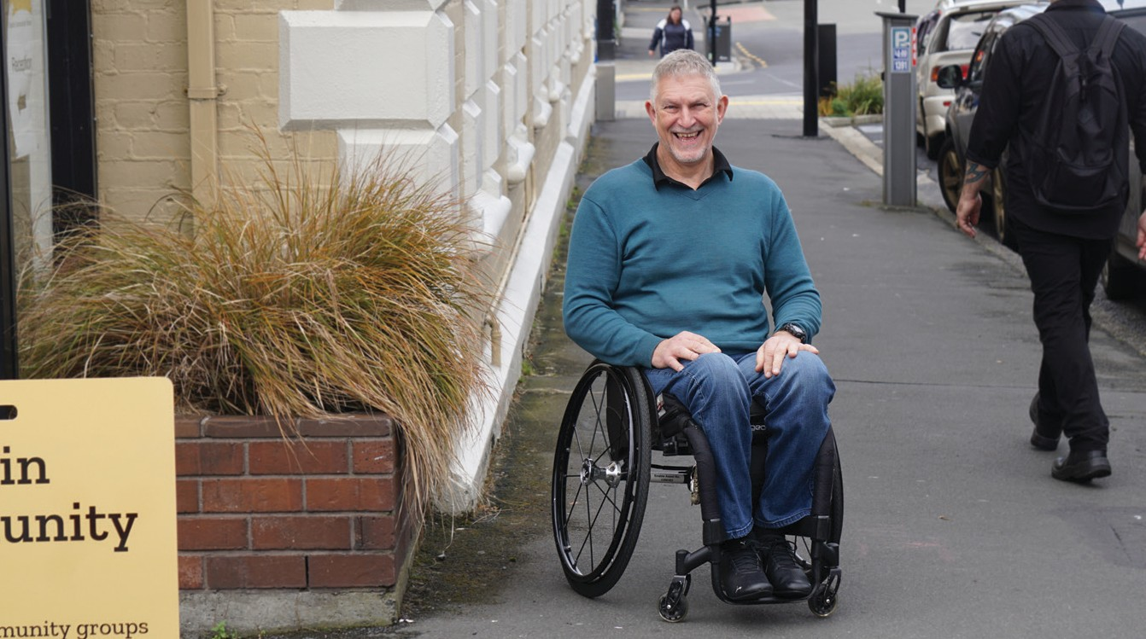

09

Our pathway towards enabling
Better health, better lives, Whanau Ora

What have our people asked for?* How will we get there? By 2026:
We work in partnership

to create a truly integrated,

- better coordinated care across providers, with less wasted time
- care closer to home
- communication that makes sense and is respectful
• a calm, compassionate and dignified experience
- high quality, equitable health services.

*Southern Future listening sessions, 2016
Creating an environment for health
The environment and society we live in supports health and wellbeing.

Primary & Community Care
Care is more accessible, coordinated and closer to home.

Clinical service re-design
Primary and secondary/tertiary services are better connected and integrated. Patients experience high quality, efficient services and care pathways that value their time.

Enabling our people
Our workforce have the skills, support and passion to deliver the care our communities have asked for.

patient-centred health care system

A health-enabling society, within which we deliver:
More accessible, extensive primary and community care with the right secondary and tertiary care when it’s needed.

So that our people:
  - are healthier and take greater responsibility for their own health
  - stay well in their own homes and communities
  - with complex illness have improved health
outcomes.

Systems for success
THE SOUTHERN STRATEGIC HEALTH PLAN
Our systems make it easy for our people to manage care, and to work together safely.

Facilities for the future
Including Dunedin Hospital, Lakes District Hospital redevelopment and community health hubs to accommodate and adapt to new models of care.

Southern DHB Disability Strategy
Rautaki Hauātaka

Vision

Wawata
Within the southern district all disabled people, tāngata whaikaha, and Deaf people will have an equal opportunity to achieve their best possible health outcomes, enabling their participation within their community. Health and disability support services will recognise the agency of disabled people, tāngata whaikaha, and Deaf people and their family or whānau through responding to their diverse requirements and removing disabling barriers.

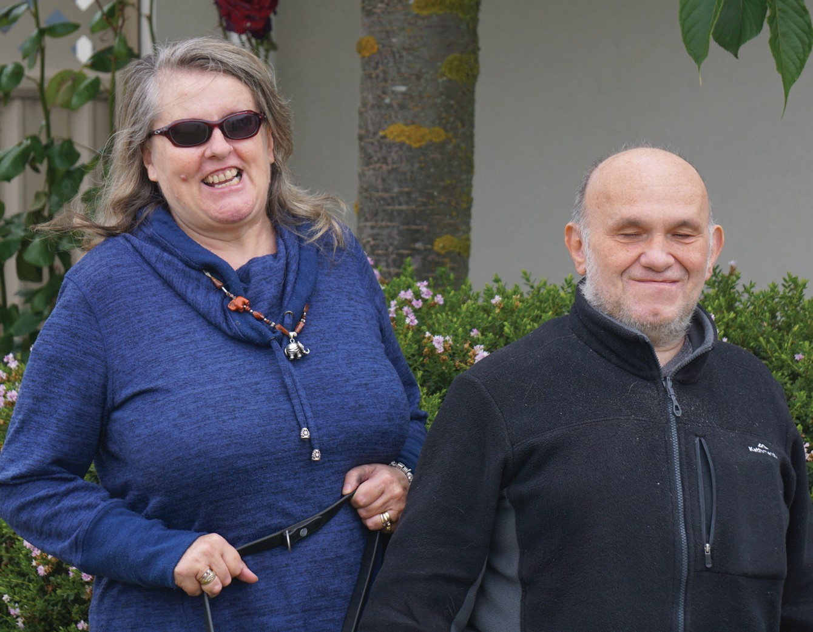

Priorities

Mahi Mātuatua
From the consultation process three goals were identified as important for Southern DHB to include in their programme of work. For each of these goals there are
a number of actions. Each goal is presented with a rationale based on what the community spoke about at consultation meetings, followed by a list of actions.

Goals and actions are not isolated. To achieve an equitable health and disability service for disabled people, tāngata whaikaha, and Deaf people within the Southern DHB district requires integration of all three goals.

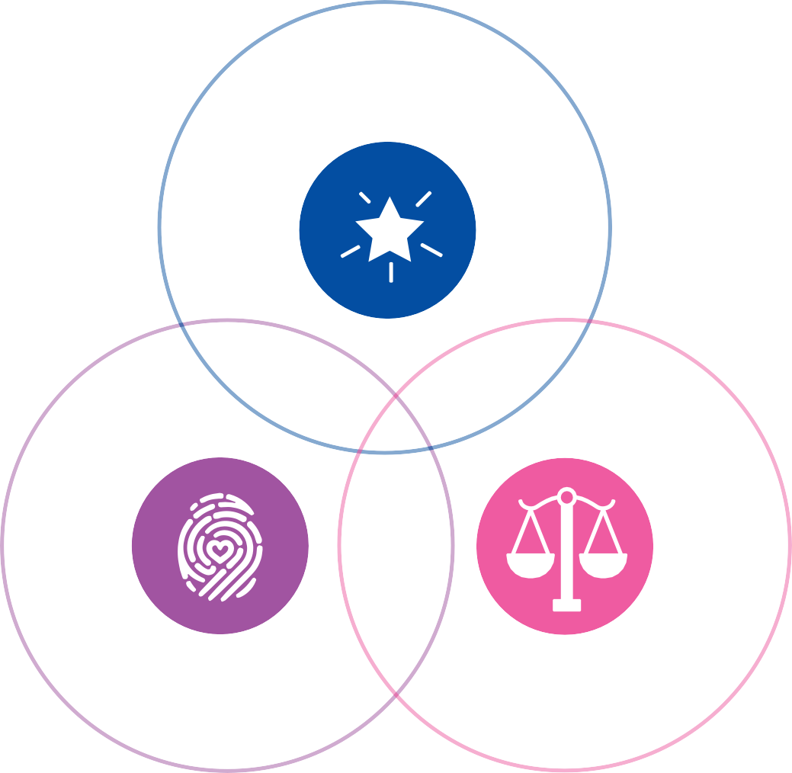
Goals

Whāika

Bold and Purposeful

Inclusive of individuals, whānau or family and community
Equitable, Responsive and Accessible

12

Bold and Purposeful

Whai take, whai māiataka

Goal:

Whāika
The southern district will be seen as a leader in the provision of health and disability services for disabled people, tāngata whaikaha and Deaf people.

Rationale:

Pūtake
Consultation identified that people saw the Southern DHB as having a responsibility for taking a leadership role within the southern district and to develop a Disability Strategy that would provide a model for the development of an inclusive community. Both immediate actions and long-term planning are required to achieve this broad goal. Southern DHB funded health and disability services to work with runaka and local organisations to ensure an all-of-community response that reflects the broad vision of Pae Ora/healthy futures, including collaboration, wide definitions of health and high quality and effective services that are shaped by the runaka or community.

This will mean:

Bold and Purposeful Whai take, whai māiataka

Nā reira
    - In all Southern DHB funded services planning will utilise a co-design approach, which will be incorporated into all the actions that follow where applicable. [DAP 3,5; MDAP 1]

    - All Southern DHB funded services will actively encourage inclusive practice including the promotion of disabled leadership at all levels of the organisation. [DAP3; UNCRPD Art 27 (e,g); MDAP 1]

    - The Executive Leadership Team will identify a member of their team to monitor and ensure that the Disability Strategy is incorporated into all the work of the organisation and in future contractual relationships. Monitoring will include regular reporting to the Community Health Council (who represent a diverse
group of consumers within the Southern DHB district); the Disability Support Advisory Committee (DSAC); and the Iwi governance committee [DAP 8; MDAP 5]

    - Southern DHB will continue to develop robust data collection processes to enable more confident planning that will ensure equity
for disabled people, tāngata whaikaha, and Deaf people accessing services, products or employment opportunities. [DAP 3, 5; UNCRPD
Art 5, 31; MDAP 5]

    - All planning will take direction from the principles of partnership, participation and protection from Te Tiriti O Waitangi. In practical terms this means ensuring that tāngata whaikaha and whānau are able to shape health and disability support services in ways that will assist them to live well. [MDAP 1,2,5)

    - All planning will incorporate universal design, reasonable accommodation, and auditing processes to ensure that the plan is accessible, addresses equity and provides a voice for disabled people, tāngata whaikaha, Deaf people and their family or whānau. [DAP 5; UNCRPD Art 25; MDAP 5]
- Southern DHB will continue to implement the Workforce Strategy and Action Plan to
achieve a representative proportion of disabled employees at an organisational level. The plan will be inclusive of appropriate support from recruitment through to establishing the person in the workplace with appropriate equipment and / or other accommodations. [DAP 2; UNCRPD Art 27; MDAP 1]

- Staff education will include raising staff awareness of disabled people, tāngata whaikaha and Deaf people and their rights under the UNCRPD, the NZ Disability Strategy and Whāia Te Ao Mārama; and continuing with development of the education strategy outlined in the Workforce Strategy and Action Plan, which will incorporate mandatory components. [DAP 6; UNCRPD Art 8; MDAP 5]

- Through the adoption of a learning organisation approach, staff will develop their knowledge and skills in working with disabled people, tāngata whaikaha and Deaf people by way of relationships with consumer groups, Iwi, the University of Otago and Otago Polytechnic. [DAP 6; UNCRPD Art 8, 25(d); MDAP 5, 6]

- Southern DHB will plan resources to allow for prompt development and dissemination of new information or technology that might improve the quality of life of disabled people, tāngata whaikaha and Deaf people. [DAP 3, UNCRPD Art 4, 9 (g); MDAP 5,6]

- Staff at all levels within Southern DHB funded services will be encouraged to use a co-design approach to identify, engage with and influence community groups, district, city and regional councils, developers and any other relevant organisation or group to ensure an accessible region. [DAP 5, 6; UNCRPD Art 3, 26, 29, 30; MDAP 4,6]

- Develop a Māori health and disability workforce that reflects the Māori population, Māori values and Māori models of practice.

- Further develop Māori health sector capacity and capability with the resources and authority to deliver kaupapa Māori and whānau-centred models of care. Including by Māori, for Māori, with Māori.

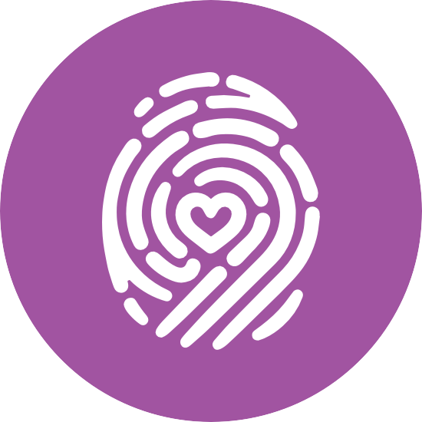

Inclusive of Individuals, Whānau
or Family and Community

Mahi Kātahi ki te Takata, te Whānau me te Hapori

Goal:

Whāika
Disabled people, tāngata whaikaha, and Deaf people and their family or whānau will have access to the support they require to live well within their community.

Rationale:

Pūtake
There was a strong message from the consultation process that disabled people, tāngata whaikaha and Deaf people and their whānau wanted better integration of services and recognition of their unique situation. Whānau Ora is a model that draws together a community around a person, enabling people to live their lives within their family and their community. The principles of this model could be seen as the way forward, as it recognises that there might be a range of people and services (including wider social services) who can support the disabled person. While valuing the individual’s rights to confidential services, people who contributed to the consultation emphasised the supporting role of family or whānau and their wider community. Community organisations also requested greater awareness and recognition of the work that they currently do to support people within their homes and communities, in order that the capacity and capabilities of their organisations are fully realised.

This will mean:

Inclusive of Individuals, Whānau Mahi Kātahi ki te Takata,
or Family and Community te Whānau me te Hapori

Nā reira

  - The development of person, family or whānau centred services, integrating the concepts
of Whānau Ora, will be incorporated into all future policy and procedures, including
pathways of care, to allow for flexibility that recognises every person’s life context, including their culture. [DAP 3, DAP 7; UNCRPD Art 28;
MDAP 1,2,3,4,5]

  - Regardless of funding models and focus, staff in all Southern DHB funded services will work in the interests of the disabled person, tāngata whaikaha, and their family or whānau towards developing seamless processes between health and disability services, social welfare (Ministry of Social Development), education (Ministry of Education) and other identified support. [DAP 3; UNCRPD Art 26; MDAP 1,2,5]

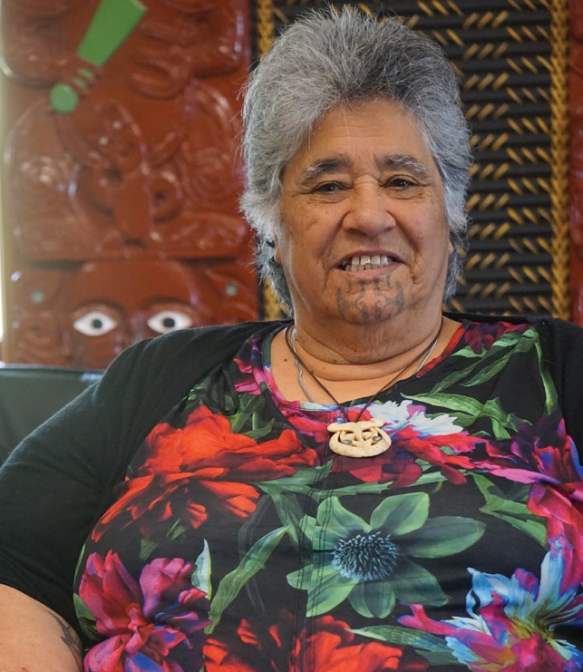
  - Family or whānau will be informed and active participants in the disabled person’s care, with the permission of the disabled person. Staff training will include consent procedures and supported decision-making, with recognition that consent decisions and capacity can change over time. [DAP 3, DAP 7; UNCRPD Art 25(d); MDAP 5]

  - Disabled people, tāngata whaikaha and Deaf people will be encouraged and assisted to complete a Health Passport as an option to express their individual preferences and needs (a roll out strategy will be developed). Health professionals will learn about, request and utilise Health Passports as routine care (to be included in staff education). [DAP 3, DAP 6; MDAP 1,2,5,6]

  - Disabled people, tāngata whaikaha, Deaf people and their family or whānau will have clear instructions on discharge or when exiting services, including how to access support, readmission procedures, and alternative support service providers. When appropriate,
all discharge planning will be inclusive of family, whānau or disability support services. [DAP 3; MDAP 1,6]

- To enable a full and satisfying life, disabled people, tāngata whaikaha, and Deaf people will be able to access appropriate support close to their home. [DAP 3; UNCRPD Art 25(c); MDAP 1,3,4]

- In all Southern DHB funded services staff will have and provide up-to-date
information on community-based services and initiate contact (with permission of the person) where that is the preference of the disabled person and/or their family or whānau. [DAP 3, DAP 7; MDAP 2]

Equitable, Responsive and Accessible

Tōkeke, Kātoitoi, Wātea

Goal:

Whāika
Through prompt and effective processes disabled people, tāngata whaikaha,and Deaf people will have access to health and disability information and services that promote their health and wellbeing.

Rationale:

Pūtake
Disabled people, tāngata whaikaha, and whānau across the district request that health and disability services are culturally responsive to their needs in order to enable them to live meaningful and productive lives. Te Taha Wairua (spirituality) holds special significance for Māori wellbeing and is reflected in relationships with people and their environment. Supporting wairua means respecting tikanga (customary practices) and leads to enhanced mana. The principle of equity requires that the Southern DHB provides the additional support that disabled people, tāngata whaikaha, and Deaf people might need to access their services and to maintain and promote their health, including strategies that address health literacy. The consultation process drew out the concerns of rural and urban communities and identified both similar and different issues for disabled people between these regions. Overall, there was a clear message that disabled people, tāngata whaikaha, their family or whānau, and other informal or formal supporters want the Southern DHB to address equity, accessibility and responsiveness for and to them as part of their Disability Strategy. The UNCRPD, the NZ DAP and Whāia Te Ao Mārama were considered to be fundamental to the development of audit processes that should be used across all services for which the Southern DHB has responsibility.

This will mean:

Equitable, Responsive and Accessible

Nā reira

  - The principle of universal design will be incorporated into all planning, including information technology, building and built environments, a current priority being the new hospital to be built in Dunedin. Using co-design will ensure final products meet the needs
of disabled people, tāngata whaikaha, Deaf people and their whānau. [DAP 5; UNCRPD Art 9; MDAP 1,2,5]

  - Staff education will include practical information, including but not limited to, tikanga, how to access interpreter services, guidelines to ensure that people’s requests are attended to promptly, and use of specialised equipment. The staff education plan will identify components that are mandatory for all staff and those that are necessary for specific groups of staff. [DAP 3; UNCRPD Art 4 (i); UNCRPD 25(d); MDAP 6]

  - Information systems will track requests for support, structural alterations or equipment both for the purpose of ensuring prompt responses to meet the person’s needs and as auditable data for later evaluation of the Southern DHB Disability Strategy. [DAP 3]

  - Southern DHB will ensure that all disabled people are able to access necessary health information, including health promotion, through having available multiple formats and strategies for dissemination. Formats will
include Māori and a range of spoken languages commonly used in the district, New Zealand Sign Language, Braille and Easy Read versions. [DAP 5; UNCRPD Art 9(2)(f); MDAP 1,6]

  - Information technology services will develop a process for disabled people and tāngata whaikaha to identify their disability and any special assistance that they require when accessing Southern DHB services or communicating with the Southern DHB. This identification will be at the choice of the disabled person. [DAP 5; DAP 7; MDAP 1,5]
- Principles of universal design will ensure that disabled people, tāngata whaikaha, Deaf people, and whānau can access all technology, including websites and portals for personal health information. Support to enable access will be available as will alternative means for those people that prefer to communicate with health services via telephone or mail. [DAP 5; MDAP 1,2,6]

- Disabled people, tāngata whaikaha and Deaf people living outside of the main cities will have equity with city residents in terms of access to the services that they need to live well. For those who have frequent outpatient appointments, reasonable accommodation means that their appointments will be arranged with consideration of their unique situation. [DAP 3, DAP 5; UNCRPD Art 25(c); MDAP 1,5]

- Southern DHB will undertake a review of how people access assistance and allowances to develop a straightforward
process to enable people to navigate their systems with ease and receive the support available to them. [DAP 3; MDAP 5]

Achievement of these goals through the planned actions will result in a health system in the southern district that upholds the values to which Southern DHB is committed. Being a part of the Southern DHB means being genuine, nurturing and maintaining relationships to promote and build on all the strengths available across the Southern DHB community.

Southern DHB Values
Kā Uara o Piki te Ora

The four values are stated as:

Kind / Manaakitanga Open / Pono
Positive / Whaiwhakaaro Community / Whanaungatanga

These values are consistent with how disabled people and their families or whānau would like to be respected. The following table incorporates quotes from the Strategy consultation
process and illustrates how people experience or would like to experience, their health journey.

Our Values | What we want to see from each other, at our best ...
Kind / Manaakitanga
Looking after our people: we respect and support each other. Our hospitality and kindness foster better care. | “I go to a medical centre – normally my doctor will come out and tap me on the arm and I go in with her. So that’s a relationship we built up – she comes out and sees me personally”. (blind woman)  “Specialists, doctors and nurses were incredibly kind to us, allowing my husband, our baby and my mother to stay both on the ward and later in a room at the rehabilitation unit.” (woman newly disabled)
Open / Pono
Being sincere: we listen, hear and communicate openly and honestly. Treat people how they would like to be treated. | “The other thing is just asking a disabled person about what they need – just talk to them! Talk to them like anybody else and they’ll talk back to you.”  “Understanding there are diverse people who will need different supports. Our people struggle to understand lots of information and visual information is much better – catering to many different needs and understanding there are differences and diversity.”
Positive / Whaiwhakaaro
Best action: we are thoughtful, bring a positive attitude and are always looking to do things better. | “There’s a nurse on the ward who’s brilliant – she goes the extra mile, understands disability, communicates really well.”  “Just in terms of culturally responsive service delivering in terms of providing the staff with support to upskill in practice and being comfortable with working with diversity.”
Community / Whanaungatanga
As family: we are genuine, nurture and maintain relationships to promote and build on all the strengths in our community. | “Speaking as a mother of a child with major health issues and disabilities. I want a more coordinated approach of where you are actually aware of what’s available and how to access it.”

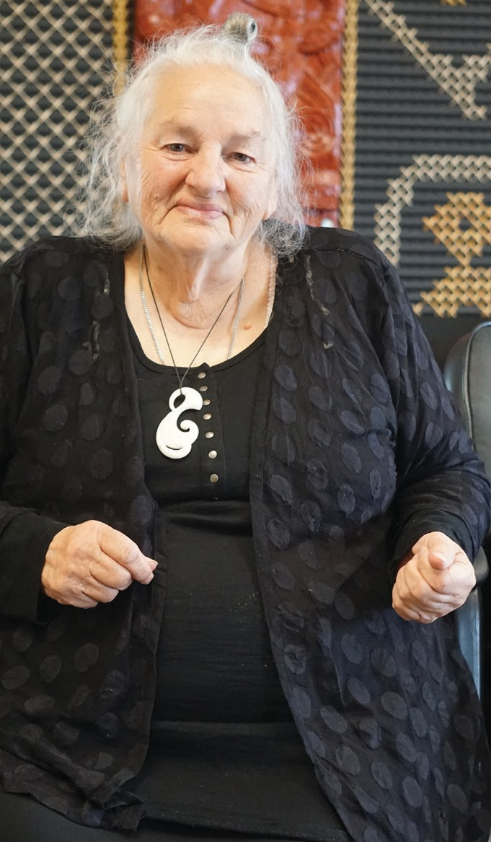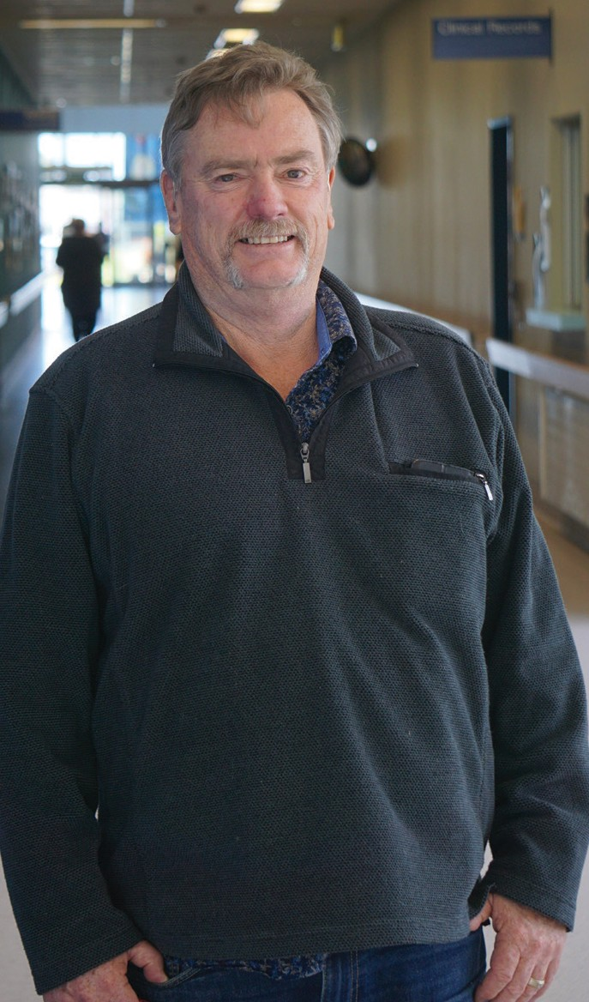
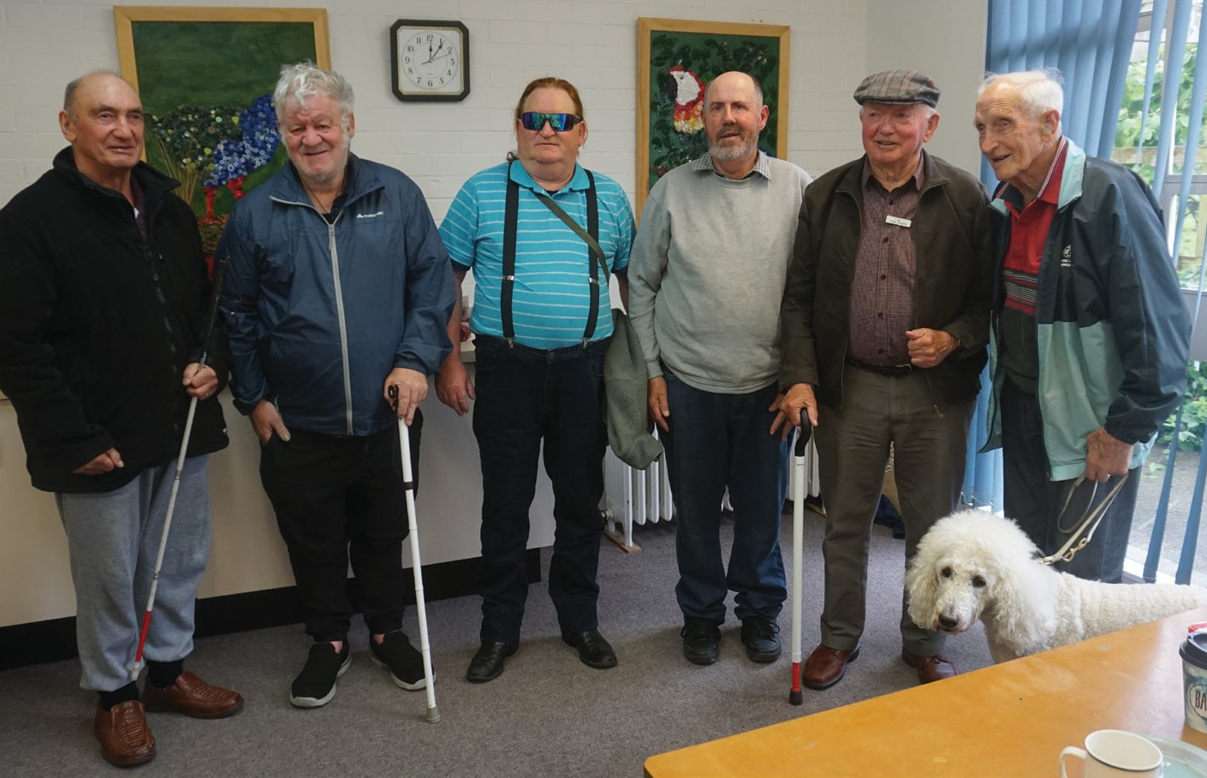

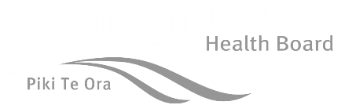
www.southernhealth.nz

